Assignment 5
WAN

- Draw a simple diagram (on paper or using an online tool like draw.io) showing how your phone connects to Instagram's servers from your home WiFi, including the ISP and at least two Wide Area Network (WAN) devices (like routers or switches) in the path.

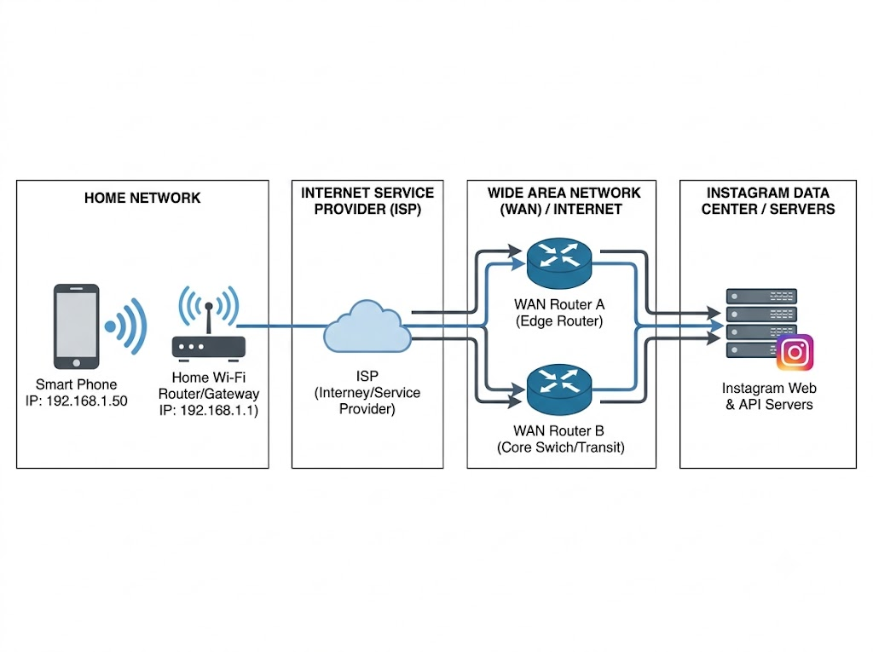

- Create a table listing three types of WAN technologies (such as MPLS, Leased Line, and Broadband Internet) and compare them based on speed, cost, and where you might see them used in real life (e.g., Zomato office, IRCTC ticketing, your home).

WAN Technology | Speed | Cost | Real-Life Usage
MPLS | High and reliable | High | Large companies like Zomato connecting multiple offices securely.
Leased Line | High and dedicated | High | Organizations like IRCTC that need reliable connectivity for critical systems.
Broadband Internet | Medium to high, depending on plan | Low | Homes, small offices, and college labs for everyday internet access.

- Research and write a short explanation of how a VPN (Virtual Private Network) uses WANs to let you access apps like Spotify or YouTube securely from a public WiFi at a coffee shop. Hint: Focus on how the VPN creates a private tunnel over the public WAN.

- A VPN (Virtual Private Network) creates an encrypted, private tunnel over a public WAN, such as the internet.

When I connect to public Wi-Fi at a coffee shop and open Spotify or YouTube, the VPN encrypts my internet traffic and sends it through a VPN server. This helps protect my data from people trying to intercept it on the public network.

Example: Public Wi-Fi → Encrypted VPN tunnel → VPN server → Spotify/YouTube.

Conclusion: A VPN improves privacy and security when using public Wi-Fi, but it does not protect against every threat, such as phishing or malware.

- Imagine Flipkart wants to connect its warehouses in Ahmedabad, Mumbai, and Delhi. Suggest which WAN technology would be best for them and justify your answer with two reasons.

- Best WAN Technology: MPLS (Multiprotocol Label Switching)

Flipkart should use MPLS to connect its warehouses in Ahmedabad, Mumbai, and Delhi.

Reasons:
- Reliable Connectivity: MPLS provides reliable, predictable network performance for sharing inventory data and managing orders across warehouses.

- Multi-Location Connectivity: It allows Flipkart to connect multiple warehouses through a managed private network, helping them communicate securely and efficiently.

Conclusion: MPLS is suitable for Flipkart because it supports reliable communication between geographically distant warehouses.

